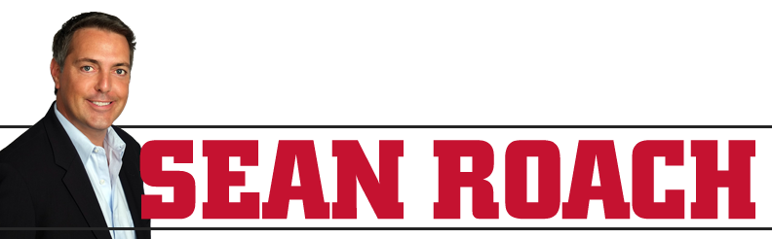

Throughout the past twenty years, Sean Roach has built an entrepreneurial empire helping businesses solve problems and realize their potential. Using his expertise in internet marketing and organizational turnaround, Sean provides practical advice on how both small and large businesses can expand their reach and reposition themselves after inevitable changes in business and technology.
At the individual level, Sean urges people to take action and make their dreams a reality by giving them the tools to pursue what they want. His best-selling business book, Get Off Your Duff and Make Your Own Damn Cheese!, encourages readers to make success happen for themselves—just as he did!
Sean’s well-known story of overcoming ADHD and dyslexia to find his own success has been an inspiration to a huge audience. He believes in paying it forward by helping others improve and succeed.
As a speaker, he shares his knowledge across a wide range of industries on tangible tactics anyone can use to achieve success. Sean inspires people to take action and make their goals a reality by giving them the tools to pursue their dreams.
Sean has worked as an adviser for Amazon, Google, MGM Resorts, BMW, Subaru, Ford, Coldwell Banker, Century 21, Inomati and many more.

